Name: Angel Minenhle Mbonani
ST 10501378

River bite Proposal
WED5020 GR1

Table of contents for the River Bite Website Proposal

Content about River Bite |  | Pages
1.Cover Page |  | 1-1
- Executive summary |  | 2-3
- 3 Key Performance Indicators (KPIs) & Two Major Successes |  | 5-6
4.Proposed Website Features |  | 6-7
5. Designing User Experience |  | 7-7
6.. Wireframes: |  | 7-9
7. Technical Requirements |  | 9-9
8. Timeline & Milestones (8 weeks example) |  | 11-11
9. Budget Estimate |  | 11-11
 | 10. References and Documentation 12

- 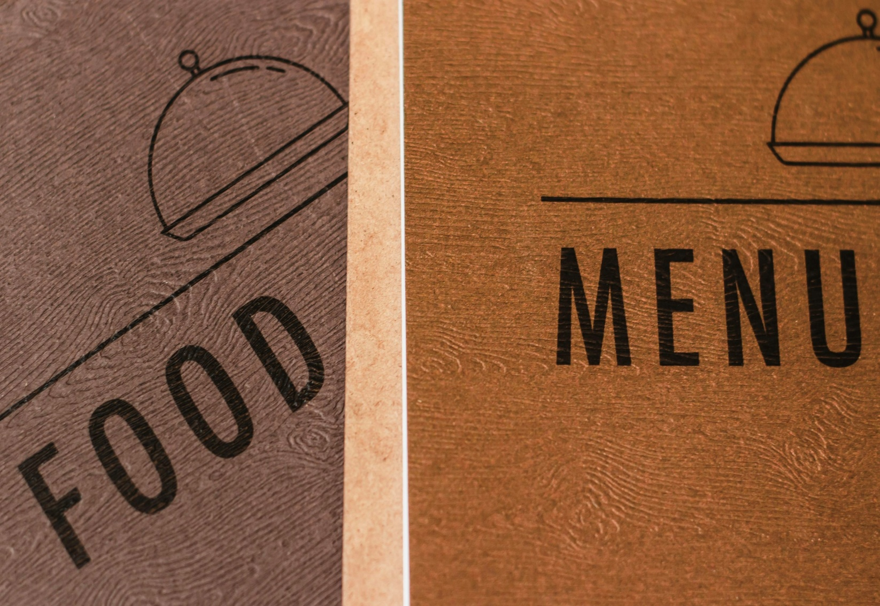

- FIRST PROPOSAL
Proposal 1 — River Bite (Restaurant)
Organizational Overview
- Project name: River Bite Website
- Organization: River Bite
- Brief history: River Bite opened in 2022 as a small riverside cafe. Over the years it grew into a neighbourhood bistro known for seasonal dishes and weekly live music.
- Mission statement: Serve fresh, locally sourced food in a warm, friendly setting and its free sitting .
- Vision statement: Be the go-to casual dining spot where community meets great food.
- Target audience: Local diners (ages 20–60), families, foodies, tourists visiting the river area.
  - Add clear menu page and visible hours
  - Add online booking and contact form
  - Optimize images and enable caching

- Website goals & objectives:
  - Main goal: Increase reservations and walk-in visits.
  - Specific goals:
    - Increase monthly website visits by 30% in 6 months.
    - Increase online reservations by 40% in 4 months.
    - Grow newsletter signups to 1,000 in 6 months.
    - Make the site easy to use on phones.
3.Key Performance Indicators (KPIs) & Two Major Successes
- KPIs to track:
  - Website visitors per month
>Mobile visits percentage
  - Online reservations per month
  - Newsletter signups
  - Average page load time
- Two major success goals:
  - Forty percent more online reservations in 4 months.
  - Get average page load time under 2.5 seconds.
Current Website Analysis (if applicable

- Current site: [insert URL] — outdated layout, no clear reservation button.
- Trends & weaknesses:
  - Low mobile friendliness
  - Hard to find menu and hours
  - Slow image loading
  - No online reservation form or broken contact link
- Areas for improvement:
  - Make site mobile-first and fast.
  - Add clear menu page and visible hours.
  - Add online booking and contact form.
  - Optimize images and enable caching.
4.Proposed Website Features
- Pages:
  - Home, About, Menu, Reservations, Events, Gallery, Contact, Privacy
- Functions:
  - Mobile-friendly layout
  - Online reservation form (or link to reservation service)
  - Menu with images and easy updates (CMS)
  - Photo gallery and events calendar
  - Newsletter signup and social links
  - Google Maps embed and click-to-call.
  - Basic SEO (titles, descriptions)
- Designing User Experience
- Design feel: warm, cozy, modern rustic.
- Colour palette (example):
  - Primary: Warm brown
  - Accent: hot pink
  - Neutral: Cream, Dark text
- UX considerations:
  - Big “Reserve” button in header
  - Simple menu with prices and dietary tags
  - Easy navigation and clear contact info
  - Fast-loading images, readable fonts
6.Wireframes:
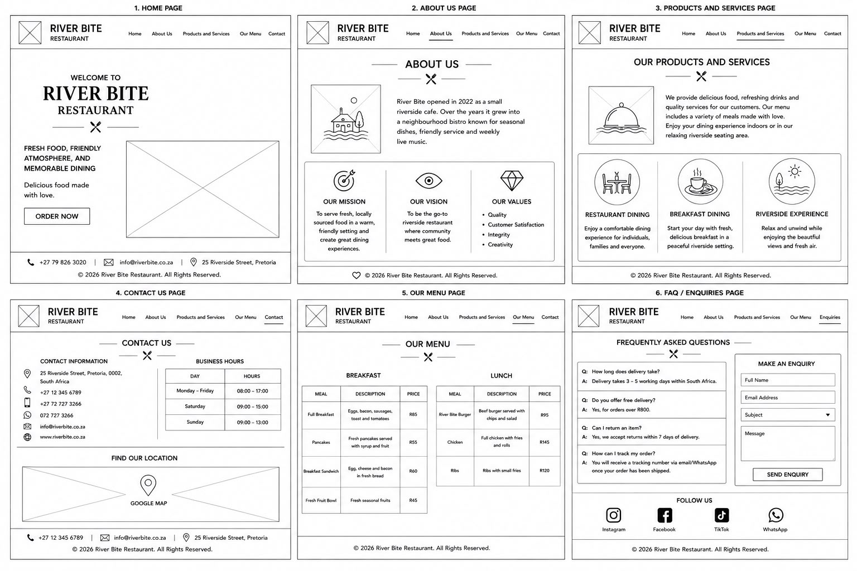

  - Low fidelity: blocks showing header (logo, reserve), hero image, menu preview, testimonials, footer.
  - High-fidelity: polished mock-ups with colours and images (to be made in Figma or similar).
7.Technical Requirements
- Hosting & domain:
  - Keep current domain or buy new one; host on shared or managed host (e.g., Bluehost, Site Ground) or Netlify for static.
  - Use Cloudflare CDN for speed.
- Languages & frameworks:
  - HTML5, CSS3, JavaScript
  - CMS: WordPress or simple headless CMS for easy updates
- Integrations:
  - Reservation service (OpenTable/Reys) or custom form with email
  - Google Analytics (GA4), Google Maps
- Security:
  - SSL/TLS certificate, weekly backups
8.Timeline & Milestones (8 weeks example)
- Week 1: Kick-off, content list, sitemap
- Week 2: Low-fidelity wireframes, collect photos/menu.
- Weeks 3–4: Design mock-ups & approval
- Weeks 5–6: Development and CMS setup
- Week 7: Testing (mobile, speed, forms)
- Week 8: Launch and post-launch checks.
- Milestones: M1 sitemap, M2 design approval, M3 staging site, M4 launch
9.Budget Estimate
- One-time build:
  - Simple site (5–8 pages): R 2000 to R 3000
  - With online booking and gallery: R4000–R5,000
- Ongoing costs (per year):
  - Hosting & domain: R50–R300
  - Maintenance & updates: R600–R2000
  - Third-party services (reservation fees, email): variable
10.References & Documentation

  - WCAG basics (accessibility)
  - Google Page Speed Insights
  - Reservation plaAccessibility: WCAG Overview — W3C (https://www.w3.org/WAI/standards-guidelines/wcag/)
  - Speed & Performance: Google PageSpeed Insights (https://developers.google.com/speed/pagespeed/insights/)
  - CDN & DNS: Cloudflare documentation (https://developers.cloudflare.com/)
  - Reservation Platforms: OpenTable (https://restaurant.opentable.com/) and Reys (or local provider) — evaluate integration and fees
  - Analytics: Google Analytics 4 (GA4) setup guide (https://support.google.com/analytics/)
  - Image optimization: Short guide — WebP, responsive srcset, lazy loading
  - Hosting options: Netlify (static), Bluehost, SiteGround — compare pricing and features
  - Design & prototyping: Figma basics for high-fidelity mockups (https://www.figma.com/resources/learn-design/)
  - tforms: OpenTable, Reys
  - Competitor local bistro sites for ideas
- Attachments to submit sitemap, wireframes, menu content, photo files, analytics (if available).

